Hamlet Character Epithet

It’s hard to keep up with how many people die in *Hamlet*. For this assignment, you will choose one dead character and create an epithet for them. Your epithet must include the following information:

1. Name of character
2. Cause of Death
3. Symbol that represents character and/or that character’s cause of death
4. 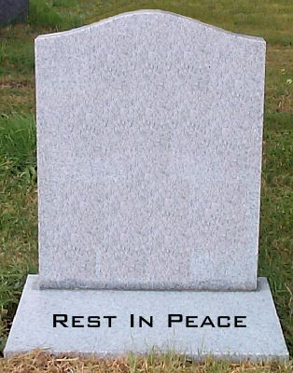A phrase that sums up the character’s life